Area Measurement
# Source: AI Source: Provided by: [Data Path: Persons Table -> ID Column: 1, Name_En Column: Motasem Essam] -> From: [ChatGPT] on [7/17/2026]
Area is the measurement of the two-dimensional surface enclosed within the boundaries of a shape or region. It describes how much surface a flat object occupies and is widely used in mathematics, geometry, engineering, architecture, construction, agriculture, mapping, and everyday life.
Area is measured in square units, such as square meters (m²), square centimeters (cm²), or square kilometers (km²).

Definition
# Source: AI Source: Provided by: [Data Path: Persons Table -> ID Column: 1, Name_En Column: Motasem Essam] -> From: [ChatGPT] on [7/17/2026]
Area is the physical quantity that measures the extent of a two-dimensional surface enclosed by a closed boundary.
Unlike length, which measures one dimension, area measures two dimensions (length × width).

Purpose
# Source: AI Source: Provided by: [Data Path: Persons Table -> ID Column: 1, Name_En Column: Motasem Essam] -> From: [ChatGPT] on [7/17/2026]
Area measurement is used to:
- Determine the size of flat surfaces.
- Calculate land size.
- Estimate construction materials.
- Measure rooms and floors.
- Design buildings.
- Calculate painting or tiling requirements.
- Solve geometric problems.

SI Unit
# Source: AI Source: Provided by: [Data Path: Persons Table -> ID Column: 1, Name_En Column: Motasem Essam] -> From: [ChatGPT] on [7/17/2026]
The SI derived unit of area is:
1 square meter (m²)
Since area is derived from length:
$$1 {\text{m}}^{2}=1\text{ m}×1\text{ m}$$

Common Units of Area
# Source: AI Source: Provided by: [Data Path: Persons Table -> ID Column: 1, Name_En Column: Motasem Essam] -> From: [ChatGPT] on [7/17/2026]
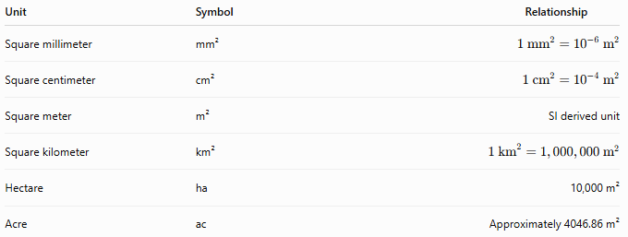
Unit | Symbol | Relationship
Square millimeter | mm² | $$1 {\text{mm}}^{2}={10}^{-6} {\text{m}}^{2}$$
Square centimeter | cm² | $$1 {\text{cm}}^{2}={10}^{-4} {\text{m}}^{2}$$
Square meter | m² | SI derived unit
Square kilometer | km² | $$1 {\text{km}}^{2}=1,000,000 {\text{m}}^{2}$$
Hectare | ha | 10,000 m²
Acre | ac | Approximately 4046.86 m²

Measuring Instruments
# Source: AI Source: Provided by: [Data Path: Persons Table -> ID Column: 1, Name_En Column: Motasem Essam] -> From: [ChatGPT] on [7/17/2026]
Area is usually determined by measuring dimensions with tools such as:
- Ruler
- Measuring tape
- Vernier caliper (for small objects)
- Laser distance meter
- Surveying instruments
The area is then calculated using the appropriate geometric formula.

Area Formulas

Rectangle
# Source: AI Source: Provided by: [Data Path: Persons Table -> ID Column: 1, Name_En Column: Motasem Essam] -> From: [ChatGPT] on [7/17/2026]
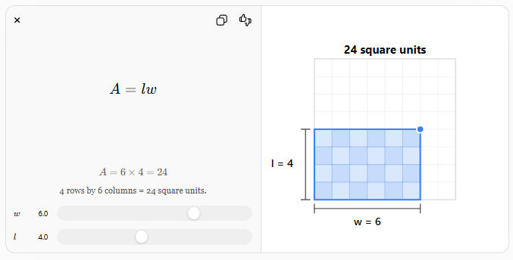
$$A=l×w$$
where:
- $A$= area
- $l$= length
- $w$= width

Square
# Source: AI Source: Provided by: [Data Path: Persons Table -> ID Column: 1, Name_En Column: Motasem Essam] -> From: [ChatGPT] on [7/17/2026]
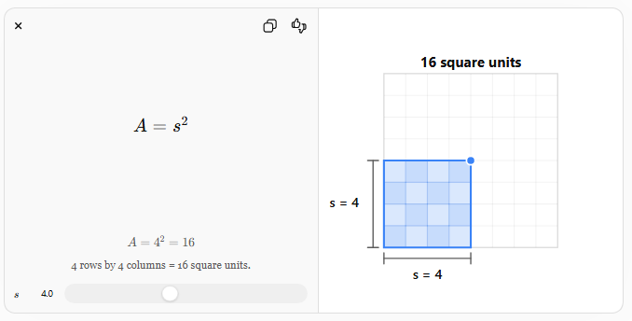
$$A=s^{2}$$
where:
- $s$= side length

Triangle
# Source: AI Source: Provided by: [Data Path: Persons Table -> ID Column: 1, Name_En Column: Motasem Essam] -> From: [ChatGPT] on [7/17/2026]
$$A=\frac{1}{2}bh$$
where:
- $b$= base
- $h$= height

Circle
# Source: AI Source: Provided by: [Data Path: Persons Table -> ID Column: 1, Name_En Column: Motasem Essam] -> From: [ChatGPT] on [7/17/2026]
$$A=πr^{2}$$
where:
- $r$= radius

Trapezoid
# Source: AI Source: Provided by: [Data Path: Persons Table -> ID Column: 1, Name_En Column: Motasem Essam] -> From: [ChatGPT] on [7/17/2026]
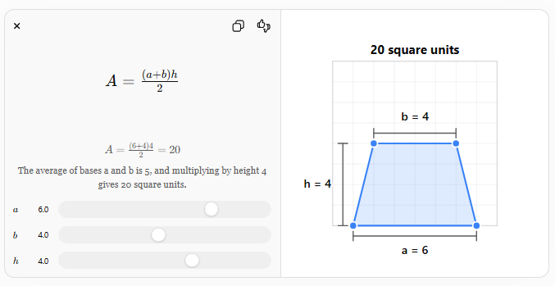
$$A=\frac{(a+b)h}{2}$$
where:
- $a$and $b$= parallel sides
- $h$= height

Measurement Process
# Source: AI Source: Provided by: [Data Path: Persons Table -> ID Column: 1, Name_En Column: Motasem Essam] -> From: [ChatGPT] on [7/17/2026]
To determine area:
- Measure the necessary dimensions.
- Select the correct geometric formula.
- Substitute the measurements.
- Calculate the result.
- Express the answer in square units.

Examples
# Source: AI Source: Provided by: [Data Path: Persons Table -> ID Column: 1, Name_En Column: Motasem Essam] -> From: [ChatGPT] on [7/17/2026]
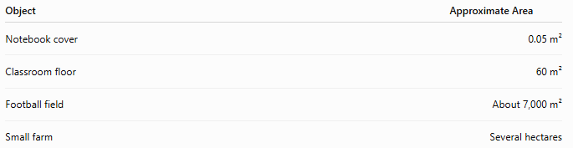
Object | Approximate Area
Notebook cover | 0.05 m²
Classroom floor | 60 m²
Football field | About 7,000 m²
Small farm | Several hectares

Unit Conversions
# Source: AI Source: Provided by: [Data Path: Persons Table -> ID Column: 1, Name_En Column: Motasem Essam] -> From: [ChatGPT] on [7/17/2026]
Common conversions:
- 1 m² = 10,000 cm²
- 1 cm² = 100 mm²
- 1 km² = 1,000,000 m²
- 1 hectare = 10,000 m²
Examples:
- 5 m² = 50,000 cm²
- 2 km² = 2,000,000 m²

Accuracy
# Source: AI Source: Provided by: [Data Path: Persons Table -> ID Column: 1, Name_En Column: Motasem Essam] -> From: [ChatGPT] on [7/17/2026]
Accurate area measurement depends on:
- Accurate dimension measurements.
- Correct geometric formula.
- Proper unit conversion.
- Suitable measuring tools.

Applications
# Source: AI Source: Provided by: [Data Path: Persons Table -> ID Column: 1, Name_En Column: Motasem Essam] -> From: [ChatGPT] on [7/17/2026]
Area measurement is essential in:
- Geometry
- Architecture
- Construction
- Surveying
- Agriculture
- Interior design
- Manufacturing
- Cartography
- Landscaping
- Environmental science

Everyday Importance
# Source: AI Source: Provided by: [Data Path: Persons Table -> ID Column: 1, Name_En Column: Motasem Essam] -> From: [ChatGPT] on [7/17/2026]
Area measurement is used for:
- Buying flooring.
- Painting walls.
- Installing tiles.
- Measuring farmland.
- Planning gardens.
- Designing buildings.
- Estimating roofing materials.

Common Mistakes
# Source: AI Source: Provided by: [Data Path: Persons Table -> ID Column: 1, Name_En Column: Motasem Essam] -> From: [ChatGPT] on [7/17/2026]
- Confusing area with perimeter.
- Forgetting to use square units.
- Using incorrect dimensions.
- Applying the wrong formula.
- Making unit conversion errors.

Key Points
# Source: AI Source: Provided by: [Data Path: Persons Table -> ID Column: 1, Name_En Column: Motasem Essam] -> From: [ChatGPT] on [7/17/2026]
- Area measures the size of a two-dimensional surface.
- The SI derived unit is the square meter (m²).
- Area is expressed in square units.
- Different shapes require different formulas.
- Accurate area calculations depend on precise length measurements.

Area vs. Perimeter
# Source: AI Source: Provided by: [Data Path: Persons Table -> ID Column: 1, Name_En Column: Motasem Essam] -> From: [ChatGPT] on [7/17/2026]
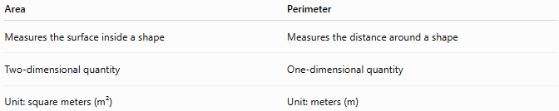
Area | Perimeter
Measures the surface inside a shape | Measures the distance around a shape
Two-dimensional quantity | One-dimensional quantity
Unit: square meters (m²) | Unit: meters (m)

Area vs. Surface Area
# Source: AI Source: Provided by: [Data Path: Persons Table -> ID Column: 1, Name_En Column: Motasem Essam] -> From: [ChatGPT] on [7/17/2026]
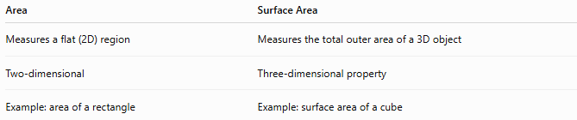
Area | Surface Area
Measures a flat (2D) region | Measures the total outer area of a 3D object
Two-dimensional | Three-dimensional property
Example: area of a rectangle | Example: surface area of a cube

Area vs. Volume
# Source: AI Source: Provided by: [Data Path: Persons Table -> ID Column: 1, Name_En Column: Motasem Essam] -> From: [ChatGPT] on [7/17/2026]
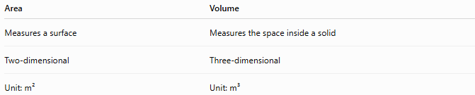
Area | Volume
Measures a surface | Measures the space inside a solid
Two-dimensional | Three-dimensional
Unit: m² | Unit: m³

Conclusion
# Source: AI Source: Provided by: [Data Path: Persons Table -> ID Column: 1, Name_En Column: Motasem Essam] -> From: [ChatGPT] on [7/17/2026]
Area is the measurement of the two-dimensional surface enclosed within a boundary. It is a derived quantity in the International System of Units, with the square meter (m²) as its standard unit. Area is calculated from linear dimensions using geometric formulas appropriate to the shape being measured. It is fundamental in mathematics, engineering, architecture, construction, agriculture, mapping, and many everyday activities that require determining the size of flat surfaces.

